* What is a real time operating system?
  + <https://en.wikipedia.org/wiki/Real-time_operating_system>
* What is a kernel?
  + <https://simple.wikipedia.org/wiki/Kernel_(computer_science)>
  + A kernel is the central (and most fundamental) part of the operating system that manages the operations of the computer and the hardware (CPU, memory, devices)
  + 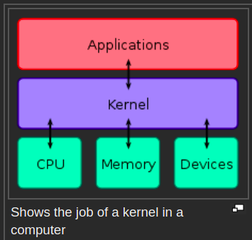
* What is a device driver
  + A device driver lets the operating system communicate with specific computer hardware
  + Computer parts need a driver when the computer parts do not use standard commands or the parts are not recognized by the computer
  + Each operating system requires its own device driver for a specific hardware (e.g. a device driver for windows cannot be used as a device driver for linux)

The two open source operating systems we are considering (Xenomai and MARTE)

* Xenomai RTOS
  + Follows IEEE POSIX guidelines
  + Extends linux
  + Has 2 ways of implementing real-time support
    - Supplementing linux with a real time co-kernel
      * Requires use of PREEMPT_RT
        + This is a very clear guide on how to do enable PREEMT_RT
        + <https://www.osadl.org/Realtime-Linux.projects-realtime-linux.0.html>
        + To use this capability you need to get

The Linux Kernel: [Linux Vanilla](http://kernel.org/)

<https://www.kernel.org/>

The Real Time Preempt Patch: [RT Preempt Download Page at kernel.org](http://www.kernel.org/pub/linux/kernel/projects/rt/)

<https://wiki.linuxfoundation.org/realtime/documentation/howto/applications/preemptrt_setup>

How ro setup PREEMPT_RT properly <https://wiki.linuxfoundation.org/realtime/documentation/howto/applications/preemptrt_setup>

* + - By relying on the real time capabilities of the native linux kernel
  + Installing Xenomai
    - You need to first need to determine which platform your computer uses
      * To find which platform your computer uses, use the commands
        + uname --help
        + uname -i
    - You then need to find your kernel source tree
      * Download the latest stable linux kernel here
        + <https://www.kernel.org/>
        + Move this downloaded folder to a comfortable location in your machine

This directory path will be what you fill in for <linux-srctree>

--linux=<linux-srctree>

--ipipe=<ipipe-patch>

--arch=--arch=x86_64

* + - * What is a linux kernel source tree?
        + <https://unix.stackexchange.com/questions/267835/what-is-a-kernel-source-tree>
    - Then you need to get your ipipe patch
      * <https://gitlab.denx.de/Xenomai/xenomai/-/wikis/Getting_The_I_Pipe_Patch>
      * In short, you need to clone
        + git://git.xenomai.org/ipipe.git
        + Each invividual pacth is for a specific matchup for the the following 2 things

Linux kernel version

Platform that your computer uses

* + - The code needed to install xenomai is here
      * <https://gitlab.denx.de/Xenomai>
      * There are two projects on this page that you should clone
        + ipipe-<YOUR_PLATFORM>
        + xenomai
    - Then follow the instructions here
    - <https://gitlab.denx.de/Xenomai/xenomai/-/wikis/Installing_Xenomai_3>
  + User space
  + What is an RTDM
    - <https://xenomai.org/documentation/xenomai-3/html/xeno3prm/group__rtdm.html#details>
* MaRTE RTOS
  + <https://marte.unican.es/>
  + Doesnt follow IEE POSIX guidelines
  + Kernel space
  + Eperimental support for java